**Introduction**

The Motion Sensor is a novelty device, which is used for amusing visitors. It moves away from the person trying to pick up cookies from the tray kept on top of it.

**Block Diagram**

The figure below shows the block diagram of the Motion Sensor-

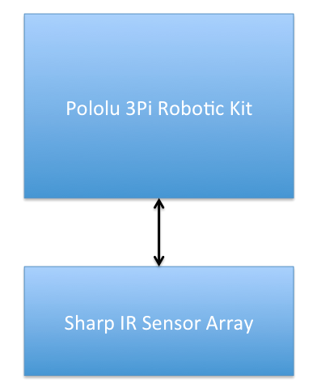

The product uses Pololu 3Pi Robotic kit. For details see the documents in the Ref folder or visit the Pololu website mention in the References section below. The sensor arrays are mounted on the edge of the containers. Whenever it detects a hand approaching the plate, it moves. The connection of the sensor to the robotic kit is as shown below-

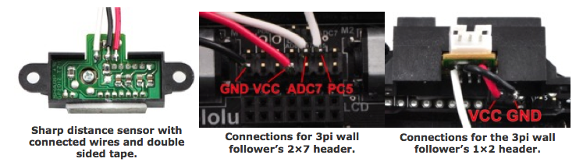

The sensors are connected to the Port pin ADC7 and PC5 of the robotic kit. The VCC and GND pins of the sensor are connected to the VCC and GND of the robotic kit expansion port.

**Components**

The following components are used-

1. Pololu 3Pi Robotic Kit
2. Sharp IR Sensors
3. Pololu expansion kit
4. Battery Adaptors

**Steps for programming**

The following are the steps for programming, for detailed steps refer to “avr_programming_quick_start_guide”-

1. Install the Atmel studio 6.1
2. Install Pololu Development bundle
3. Setup programmer
4. Import the project
5. Connect the programmer to the robotic kit and PC
6. Program the kit using the Atmel Studio IDE.

**Links**

1. [www.pololu.com](http://www.pololu.com) - Details about Pololu Robot
2. <http://www.mgsuperlabs.co.in> - To buy Pololu Robot